Aseg User Manual

by Barry Branham Mar 28, 2020

Aseg is a program for doing atrial segmentation from CAT or MRI images. It is still under development and unfinished. I would like to continue working on it after I retire so maybe it will eventually be finished.

Aseg

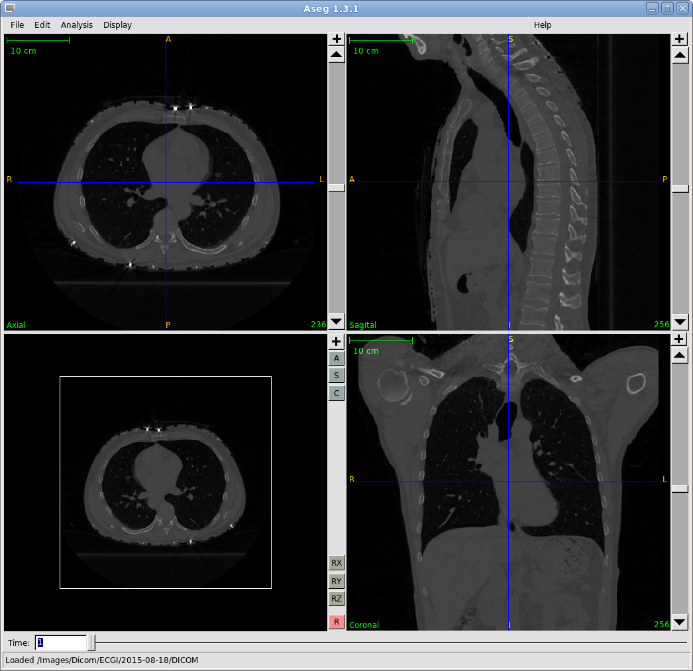

As can be seen in the above image there are four windows, three for axial, sagital and coronal image views. Each has a slider on the left for selecting which image to view. The fourth window is a 3D view and can be rotated with the mouse.

Rotated 3D Window

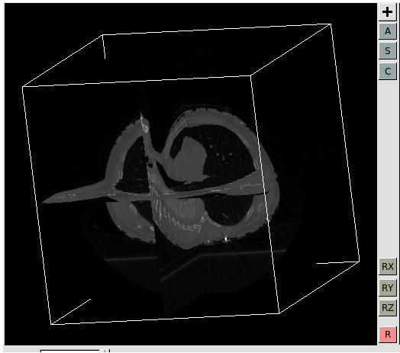

At the left of the 3D window are 8 buttons. The ‘+’ button is on all the windows and brings up a new separate larger window of that window. The ‘A’, ‘S’ and ‘C’ buttons turn the atrial, sagital or coronal images off or on in the 3D window. The ‘RX’, ‘RY’ and ‘RZ’ buttons rotate the view 90 degrees on the x, y or z axes. The ‘R’ button resets the view orientation.

The menubar

The menubar has ‘File’, ‘Edit’, ‘Analysis’, ‘Display’ and ‘Help’ items.

File

The ‘File’ item contains several ‘Load’ and ‘Save’ options. The top item is ‘Do Start Ops’. There is a corresponding ‘Save Start Ops’ item at the bottom. If, for example, you loaded images, a region of interest (ROI) and a segmentation and then clicked ‘Save Start Ops’, then the next time you run Aseg you could select ‘Do Start Ops’ and those three load operations would be performed. The ‘load’ operations are for images, a region of interest (ROI), ‘bubbles’ which are start areas for growing a segmentation, ‘segmentation’ is miss named, it actually loads an image to use for initializing a segmentation, ‘Init Mesh’ for loading a polygonal data structure for initializing a segmentation. The idea is to start a segmentation from a previous generic segmentation. Finally ‘Walls’ for loading a previous segmentation. There are corresponding ‘Save’ operations for each of the above.
Edit

The ‘Edit’ item contains options for setting parameters, creating bubbles and clearing a current segmentation. There area also options for drawing, editing and deleting walls, and for drawing and deleting a circle.

Analysis

The ‘Analysis’ item contains options for performing a segmentation, registering a model, calculating a segmentation volume, and (unrelated to segmentation) analyzing images for fibrosis.

Display

The ‘Display’ item contains many options for display. It also has options for setting the region of interest (ROI) and registering a mesh. Display options include bubbles, the initial mesh, the registered mesh, the ‘speed’ image which is used in a level set for segmentation. ‘Show initial shape’ displays the starting segmentation, ‘Show Snake’ displays the snake segmentation in the views. ‘Show Segmentation’ displays the regular segmentation in the views. If fibrosis analysis was done there is a ‘Show Fibrosis Threshold’ option. Finally there are ‘Show Pixel Value’, ‘ShowXY value’ and ‘Show image info’ options.

